Prevalence of Unintentional Injuries and Associated Risk Factors Among Children 5 Years and Below
A National Survey in Saudi Arabia
Students Name
Students Course
Institutional Affiliation
Professors Name
Date

Prevalence of Unintentional Injuries and Associated Risk Factors Among Children 5 Years and Below
Objectives
The major objective of conduction the Following Survey on Prevalence of Unintentional Injuries and Associated Risk Factors Among Children 5 Years and Below include the following. The first objective for the survey is Measuring the prevalence of Unintentional Injuries among children 5 years and Below. Prevalence can be defined as a select proportion of population suspected to have select characteristics. In the survey prevalence is percentage of children categorized with unintentional injuries identified by the survey. The second objective of the national survey is Measuring the causes of injuries among children associated Risk Factors. Risk factors can be defined as characteristic that heightens the chances to exposure to a certain entity. Risk factors in the survey include the characteristic that increase chances of unintentional injuries in children.
Introduction
Child injuries are currently among the leading health issues that can be preventable depending on the parent’s attitudes towards children's safety. Parental factors are highly related to childhood injuries, according to research. Children's injury cases increase as the child grows with age. This result from increased child activities like movement, which calls for a parent's full attention (İnce et al., 2017). Parents’ adherence to home safety decreases unintentional risks of child injuries. Parents' attitudes towards home safety are also directly associated with the level of education and occupation. Children whose parents have studied up to university levels have lower injury risks than primary school level children (İnce et al., 2017).
According to WHO, an estimate of over 630,000 children below 15 years die from injuries (Reddy & Dhaniwala, 2020). If a child suffering from injuries does not pass, they may undergo various disability degrees, while in case of minor injuries, the child can get back to normal. Most children's injuries are unintentional, with no evidence of their predetermined intent (Alkhamis& Abdulkader, 2020). According to research, most injuries resulted from falls where children fall as they try to reach objects or move. Other causes include burns, wounds from the cut by sharp objects, and electric shocks. The table below displays results from research conducted by (Alkhamis& Abdulkader, 2020) which displays the prevalence and characteristics of unintentional child injuries.
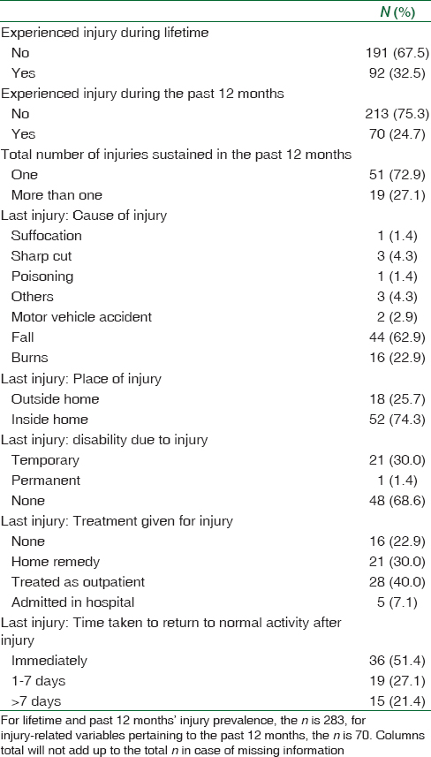
Figure 1Prevalence and characteristics of unintentional childhood injuries (n=283
Childhood injuries are common since the mental ability is not yet developed for them to prevent accidents on their own. Child injuries mainly occur due to the parent or guardian negligence responsible for looking after the child. A child is entitled to compensation for such kind of damage. Some types of child injuries are caused by parents or guardian abuse as they try to discipline them. Child injuries can result in long-term health problems, social, educational, or physical disabilities.
Parents and guardians play a significant role in a child's life to ensure the child is not exposed to injuries. Parents should be educated on the stages of child development and what to expect in each step to take necessary precautions to ensure child safety. In case a child suffers from any injury, they should be taken to specialists for treatment. Every person should play their part in ensuring good care is taken to prevent children from any accidents and injuries (Rössler et al., 2014). The purpose of this research will be to measure the attitudes of parents towards home safety, causes of injuries among children, and raising awareness on child injuries to parents. A similar survey by (Alkhamis& Abdulkader, 2020) which analyzed selective attitudes of different parents towards aspects suggested as risk factors identified that an average majority were aware of the factors. The research will aid in a more literate and conversant survey that can be understood by all individuals thus reduce the prevalence of unintentional child related injuries.
Methodology
To conduct the survey the we have incorporated the following methodologies. The primary methodology in consideration is the use of cross-sectional study. Cross sectional study involves observational study of select group of population in a given span of time. Cross-sectional study is effective when analyzing prevalence of a certain entity as is the case in our survey. As result the survey will involve transverse study of collected questionnaires on the prevalence of unintentional child injuries. the select group on which the survey will be conducted on is mother of a child. The survey will entail an expectation time of six months for completion
Data collection
The data collection method to be used in conducting the survey involves calling and online survey. This will entail calling of the study group that is mother of a child thus prompting them for an oral questionnaire. Also, data collection will involve brief online surveys on the target study groups which will contain similar questionnaire. The calls and online surveys will be designed in manner compatible with all literate groups in the society. The questionnaires in the calls and online surveys will be subject to validation by three experts.
Data analysis
Analysis of the collected data will involve the use of analysis software such as SPSS. SPSS (Statistical Package for the Social Sciences) is a statistical analysis software that aids in formulating tables and charts. The analysis software will enable create tables and charts essential in comparison of certain aspects thus aid in determining the prevalence of unintentional child related injuries

References
Alkhamis, K. N., & Abdulkader, R. S. (2020). Assessment of unintentional childhood injuries and associated factors in a tertiary care hospital’s pediatric clinic in Riyadh, Saudi Arabia. Journal of Family & Community Medicine, 27(3), 168.
İnce, T., Yalçın, S., & Yurdakök, K. (2017). Parents’ attitudes and adherence to unintentional injury prevention measures in Ankara, Turkey. Balkan medical journal, 34(4), 335.
Reddy, S. M., & Dhaniwala, N. S. (2020). Outcome of Surgically Managed Diaphyseal Fractures in Children-A Prospective Study. JOURNAL OF EVOLUTION OF MEDICAL AND DENTAL SCIENCES-JEMDS, 9, 393-97.
Rössler, R., Donath, L., Verhagen, E., Junge, A., Schweizer, T., & Faude, O. (2014). Exercise-based injury prevention in child and adolescent sport: a systematic review and meta-analysis. Sports medicine, 44(12), 1733-1748.

